

**RIVERS STATE UNIVERSITY**

**P.M.B 5080, NKPOLU-OROWORUKWU**

**PORTHARCOURT**

**DEPARTMENT OF MARINE ENGINEERING**

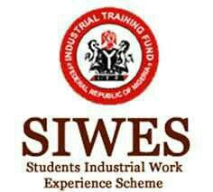

**A SIX (6) MONTHS TECHNICAL REPORT ON STUDENT INDUSTRIAL**

**WORK EXPERIENCE SCHEME**

**AT**

**HENRY SPENCER NIGERIA LIMITED TRANS-WOJI**

**PORTHARCOURT RIVERS STATE**

**BY**

**EMMANUEL DAN-JUMBO**

**FACULTY OF ENGINEERING (MARINE DEPARTMENT) OF THE RIVERS STATE UNIVERSITY NKPOLU-OROWORUKWU**

**ABSTRACT**

The objective of The Student Industrial Work Experience Scheme (SIWES) are the provision of an Avenue For Students In Universities To Gain Industrial Skills And Experience In Their Course Of Study. I Did My Industrial Training At A Reputable Marine Company (HENRY SPENCER NIGERIA LIMITED). There Were Various Departments of Which The Trainees Where Assigned To. I was Personally Assigned To The Engine Room Department.

**DEDICATION**

I dedicate this Report to the most high who has been always there to see me through my time of attachment at HENRY SPENCER NIGERIA LIMITED. I also dedicate this report to my family for their wonderful support and assistance throughout the attachment programme. May God bless them all.

**ACKNOWLEDGEMENT**

My time at my place of attachment (HENRY SPENCER NIGERIA LIMITED) as an I.T personnel from September 2021, through February 2022 was a memorable one. As I get to meet and relate with able Marine personnels and also get a live experience working on a vessel. It helped me gain a lot of sea time experience also, as we had to test run some vessels which we worked on. My Industrial training made me realize most Marine related operations.

**TABLE OF CONTENTS**

Title Page i

Abstract ii

Dedication iii

Acknowledgement iv

Table of Contents v

**CHAPTER 1: INTRODUCTION**

* 1. History of SIWES
  2. General Objective of SIWES
  3. Benefits of SIWES
  4. Importance of Industrial training
  5. About the Company
  6. Services Offered
  7. Mission Statement
  8. Company Main Goal
  9. Company Strategic Planning
  10. Company Client

**CHAPTER 2: INDUSTRIAL EXPERIENCE AND ATTACHMENT PROGRAMME**

2.1 Running and maintenance of company base engines

2.2 Engine Starting Procedure

2.3 Sound

2.4 Vibration

2.5 Oil gauge and dip stick

2.6 The exhaust

2.7 The breath out

2.8 Precaution

2.9 Work challenges

**CHAPTER 3: SKILLS ACQUIRED AND CHALLENGES**

3.1 New Skills Acquired

3.2 Challenges Encountered

**CHAPTER 4: CONCLUSION AND RECOMMENDATIONS**

4.1 Conclusion

4.2 Recommendation

Reference

Appendix I

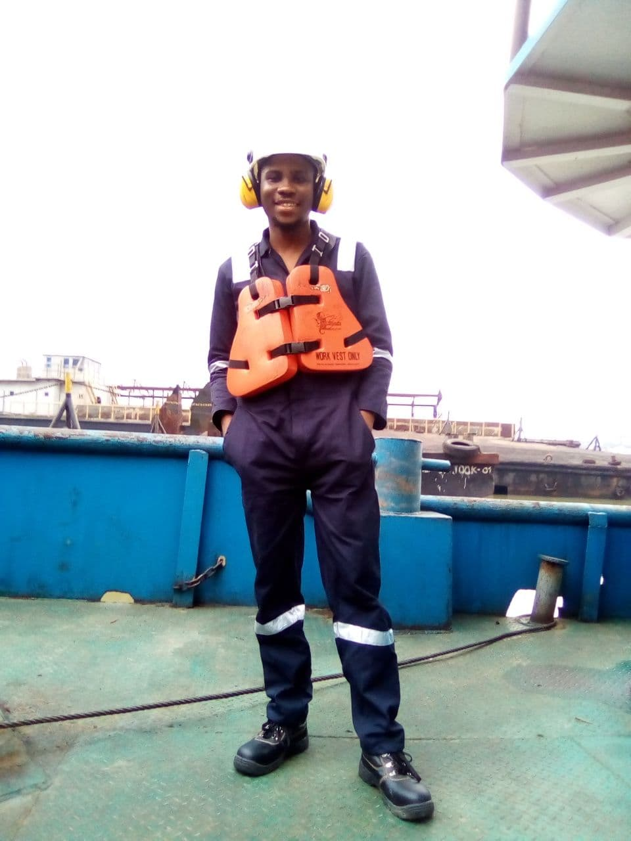

**CHAPTER 1**

**INTRODUCTION**

* 1. **History of SIWES**

SIWES was established by ITF (Industrial Training Funds) in the year 1973 to solve of lack of adequate proper skill for employment of Tertiary institution graduates by Nigerian Industries. The Students Industrial Work Experience Scheme (SIWES) was founded to be a skill training programme to help expose and prepare students of Universities, Polytechnics and Colleges of Education for the industrial work situation to be met after graduation. This skills serves as smooth transition from the classroom to the world of work and further helps in the application of knowledge. The scheme provides students with the opportunity of acquainting and exposing themselves to the experience required in handling and managing of equipment and machinery that are usually not made available in their institution.

Before this scheme was established, there was a growing concern and trend noticed by industrialists that graduates of higher institutions lack sufficient practical background for employment. It used to be that students who got into Nigerian institutions to study science and technology were not trained in the practical know-how of their various field of study. As a result, they could not easily find jobs due to the lack of working experience.

Therefore, the employers thought that theoretical education going on in the higher institution was not responsive to the needs of the employers of labour. This was a huge problem for thousands of Nigerians until 1973. It is against the background that the fundamental reason for initiating and designing the scheme by the fund in 1973/74 was introduced.

* 1. **GENERAL OBJECTIVES OF SIWES**

SIWES is strategized for skill acquisition. It is in fact designed to prepare and expose students of universities, polytechnics and colleges of education to the real-life work situation they would engage in after graduation. Therefore, SIWES is a key factor required to inject and help keep alive industrialization and economic development in the nation through the introduction and practical teaching of scientific and technological skills to students. (Culled from Detailed Manual on SIWES Guidelines and Operations for Tertiary Institutions). Objectives of the Students Industrial Work Experience Scheme include:

1. Provide an avenue for students to acquire industrial skills for experience during their course of study
2. Expose students to work methods and techniques that may not be available during their course of study
3. Bridging the gap between theory and practice by providing a platform to apply knowledge learnt in school to real work situations
4. Enabling the easier and smoother transition from school by equipping students with better contact for future work placement
5. Introduce students to real work atmosphere so that they know what they would most likely meet once they graduate.
   1. **IMPORTANCE OF SIWES**

All Nigerian students who study technology and science must know about SIWES. Partaking in SIWES has become a prerequisite for the award of diploma and degree certificates in many Nigerian Institutions according to the Nigerian government Educational policy. Undergraduate students of the following discipline are expected to be a part of the scheme.

Before this scheme was established, there was a growing concern and trend noticed by industrialists that graduates of higher institutions lack sufficient practical background for employment. It used to be that students who got into Nigerian institutions to study science and technology were not trained in the practical know-how of their various field of study. As a result, they could not easily find jobs due to the lack of working experience. But now SIWES made it easier for student to get jobs from these employers.

* 1. **The Benefits of Industrial training**

The major benefits accruing to students who participate conscientiously in industrial training are skills and competencies they acquire. These relevant production skills remain a part of the recipients of industrial training life-long assets which cannot be taken away from them. This is because the knowledge and skills acquired through training are internalized and become relevant when required to perform jobs or functions.

Several other benefits can be obtained by students who participate in industrial training. These include the following:

1. Preparing Students for employments and making the transition from school to world easier after graduation
2. Enabling students appreciate work methods and gain experience in handling equipment and machinery which may not be available in their institutions.
3. Provision of an enabling environment where students can develop and enhance industrial attributes such as critical thinking, creativity, initiative, resourceful, leadership, time management presentation skills and interpersonal skills amongst others.
4. Exposure of students to the environment in which they will eventually work, thereby enabling them see how their future professions are organized in practice.
5. Opportunity for students to blend theoretical knowledge acquired in the classroom with pratical hands-on application of knowledge of knowledge required to perform work in industry.
6. Minimization of the bewilderment experience by students, particularly those from a non technological background, pursing courses in science, engineering with regards to different equipments, processes, tools etc. available in industry.
   1. **About the Company**

My Industrial Training was done at Henry Spencer. Henry Spencer is a registered private limited

company solely owned by Nigerians and incorporated under Nigeria law, since 14th November, 2001

with registration number **RC43387**.

It is an indigenous diversified company that renders services in marine logistics, oil and gas construction

engineering services and construction, manpower supply, procurement and materials distribution,

environment and waste disposal to the oil and gas industry.

It also provided specialized services in engineering procurement, construction, commissioning start-up

and maintenance for on-shore and off-shore oil and gas projects, flow line and pipeline construction,

chemical/construction plant, flow stations terminals, industrial installations and major mechanical

construction work.

Henry Spencer Nigeria limited has numerous construction equipment for both land and marine

operation at its disposal our health safety and environment manual are available for verification and we

intended to abide by the laid down procures and plans therein stated. So also is our relationship with

host communities where we shall be executing our projects personnel who have plan is to have series of

quality audits internally before the client is invited for pre-comissions inspection audits.

* 1. **Services Offered**

1. **Marine Logistics**
2. Tug Boat
3. House Boat
4. Barges
5. Offshore Vessels

1. **Mechanical**
2. pipelines construction and maintenance
3. Flow lines and gas lines construction and maintenance
4. Flow station upgrade/maintenance
5. **Civil**
6. Marine installation ramp jetties-construction/maintenance
7. Water treatment facilities repair/maintenance
8. Dredging works (pre and post dredging operation)
   1. **Mission Statement**

The sole mission of Henry Spencer Nigeria LTD is to provide total quality services at a reasonable cost

and within the shortest possible time, while sustaining a stable and expanding organization using the

latest technology available worldwide and competent personnel as well as helping to develop host

communities.

* 1. **Company Main Goal**

To create a strong relationship with their clients and provide reliable, honest and creative solutions to

problems and together achieve higher levels of productivities and profitability without business.

* 1. **Company Strategic Planning**

It is the dream of Henry Spencer Nig LTD to provide a corp of local high technical personnel with a drive of excellence using modern cutting edge technology to achieving set gaols in other to achieve this, Henry Spencer has set out the following:

1. Putting reward scheme in place
2. Constant training to bridge gap
3. Goal setting/objectives for department
4. Constant monitoring/assessment
5. Putting control measure in place
   1. **Company Client**
6. Belema oil producing limited
7. Nigeria Agip oil company (NAOC)
8. Nest oil Nigeria limited
9. Shell petroleum development company of Nigeria (SPDC)
10. Rivers State Environment Board

**CHAPTER 2**

**INDUSTRAL EXPERIENCE**

A detailed report of my Industrial experience would be explained in this chapter.

On the 27th of September 2021, my first day at Henry spencer Nigeria Limited, I was introduced to the founder, Workers and vessels of the company. My first few experiences were the introduction to safety equipment (which were my coverall, safety boots, gloves, helmets etc..)

I was also shown some vessels like the “Lady Florence” vessel, Bilges etc. and had a tour around the company.

I was posted to the engine department which where I had to learn somethings about the engine. I would be explaining my experience with the engines in this chapter.

**2.1 Running and maintenance of company based engines**

We carried out routine check on the engine performance, by checking the pressure gauge, the dip stick, sound, exhaust, breath out and the vibration of the engine to ensure it is in a good working condition.

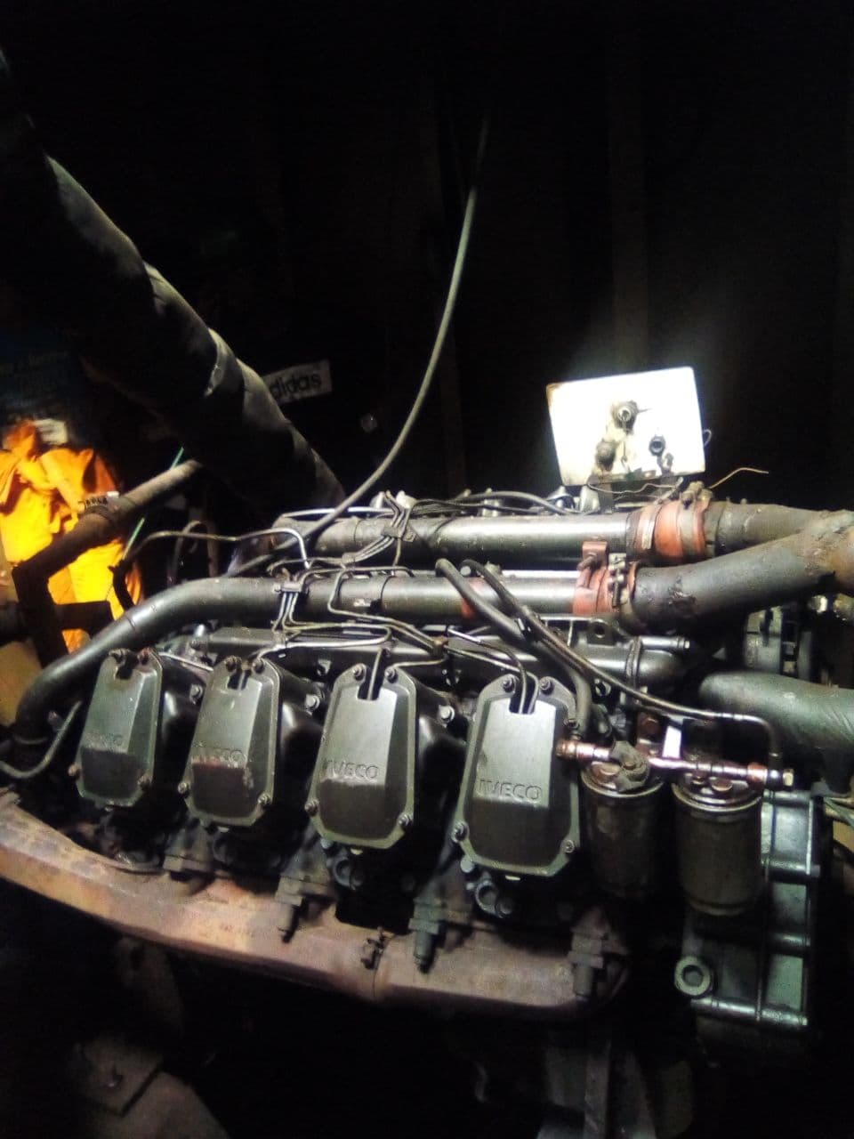

**2.2 Engine Starting Procedure**

* We do a work around inspection on the engine, checking for leakage or loose bolt
* We Check the fluids: the radiator, the oil gauge, the dip stick and the diesel tank
* We make ensure that our battery terminal is well connected and we note the starting time.

The following are the things, we watch out for during our daily watch keeping

**2.3 Sound**

The sound of the engine should be steady, any increase or decrease show load increment or decrement.

**2.4 Vibration**

Vibration is affected by transient load and the type of mountain use, engine without resilient mountains vibrate more

**2.5 Oil gauge and dip stick**

The oil gauge in the power house is normal at 50 psi.We inspect the dip stick before starting the engine and when we notice abnormality we check the gauge.

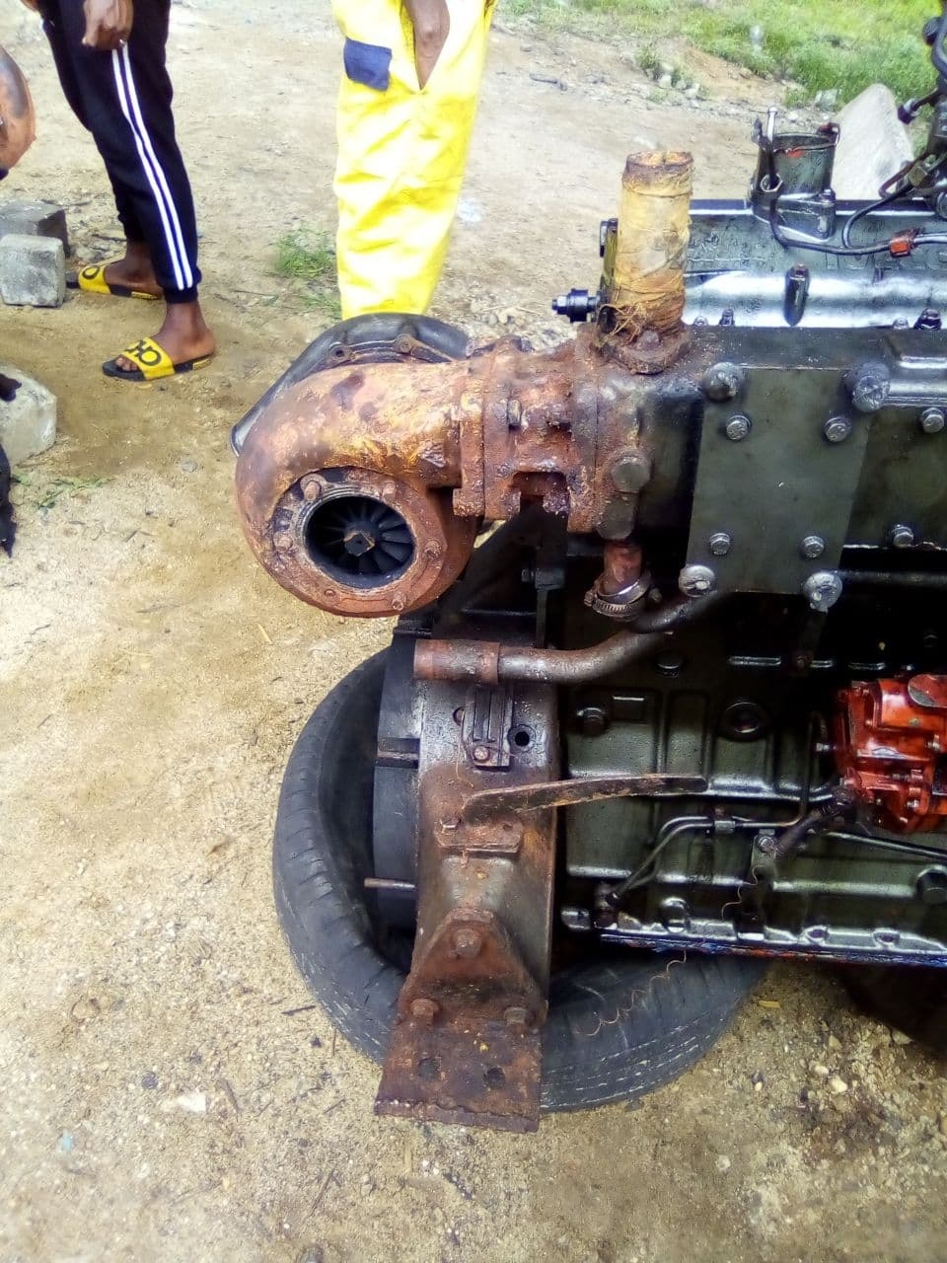

**2.6 The Exhaust**

The exhaust should be sky blue. A too white exhaust post a sign of knocking and too thick and fire mix exhaust show incomplete combustion cause by abnormal ignition or dirty in the air filtering system

**2.7 The Breath Out**

The normal smoke from the breath out is fairly white, worm and not too obvious smoke any deviation from that will indicate that something is wrong in fluid system of the engine.

The following are what we check up monthly

* The running hour
* The air filter for dirt
* The radiator coolant
* The diesel tank to remove splurges and sediment

**2.8 Precaution**

* We maintain clean and oil free environment
* We emphasis ear muffler in power house and complete personal protective equipment

**2.9 Work Challenges**

* The alternator of all the engines except the one in power house is not working and the batteries is not always charging, we have to carry the heavy batteries from power house to their respective locations.
* Frequent removal and plugging of the batteries terminal head gradually destroy the batteries.

**CHAPTER 3**

**NEW SKILL ACQUIRED AND CHALLENGES ENCOUNTERED**

* 1. **New Skill Acquired**

My experience at my place of attachment was an interesting one as a got to learn several helpful skills that are essential to myself as an aspiring marine engineer.

During the course of my six (6) months industrial training I was able to acquire the following skills:

1. **Technical Skills:** During my industrial training. I was taught on how to start, monitor sound and regulate the temperature of the engine. I was taught on how to open up the fuel line, fresh water lines, sea water line, and lubricating line and how to take fuel from the bunker tank to the service tank. Also I was taught how to pump out sewage on board vessel and how to take line when a vessel is being bat alongside your vessel.
2. **Engine Repair and Maintenance Skill:** In the course of my training, I was opportune to work in the engine room department where I learnt to repair and maintain an engine as well as its part and the procedures involved in doing so. I was also told at this section that it is very necessary to identify the problem or fault of an engine before engaging in its repair.
3. **Safety Skill:** Safety is a key factory when it comes to any marine operation. Hence, the workings of several safety equipments as well as other safety rules was taught at my place of attachment (HENRY SPENCER NIG LTD)
4. I learnt how to use the cutting torch to cut steel metal
5. **Swimming Skills:** I also learnt some swimming skills. Although I’m not yet perfect at it.
   1. **Challenges Encountered**

During my stay at Henry Spencer Nigeria limited I faced some challenges and some are listed below:

1. **My work in Engine room:** The engine was running at a very high temperature. Too much particles block the radiator vents, making it very difficult for air to enter radiator to cool the coolants

**Solution:**

The radiator was washed of the dirt that blocked the vents

1. The entire activities carried out In the site, is been contracted so we were not allowed to touch most of the equipment that is not the company properties.
2. **Lack of stipends:** Many IT students had to come from far distance (like myself) and had serious transport issues as there wer’ent any form of stipents to support the students
3. Engine exhaust emitting too much black and grey smoke. This could be harmful for IT students without proper safety equipments.

**CHAPTER 4**

**CONCLUSION AND RECOMMENDATION**

* 1. **Conclusion**

The aim of organising Siwes for student by the federal government and the school administration was achieved as stipulated in the section 1.2 of this report.

Student industrial work experience scheme is a medium of exposing the student to industrial environment, which enables us to handle and operate both industrial and marine operation equipments.

* 1. **Recommendation**

My recommendation is on SIWES and health safety environment of the industry base on the problem encounter in the chapter three of these report and it is listed below.

1. The ITF or the school administration should organize an orientation programme for the company before sending student to the company.
2. The government should pay student their allowance monthly during the siwes programme to encourage the student.
3. Institute base supervisor should visit student every two month and comment in their log book appropriately to keep the student focus

**4.2.2 HEALTH SAFETFY ENVIRONMENT**

1. The company should restrict waste disposer close to the gate and look for means to remove the present ones. To enhance decency and unpolluted environment
2. Disposer of oil and non decomposable substance in the water should be prohibited
3. Waste bins should be position in the workshop and other strategic place to easy waste disposer.

**REFERENCES**

SPC (2001). Diesel Engine learner guide [online] available at <https://www.SPC.int>

Paul ukah (2014).*Technical report on student industrial work experience scheme*.[online serial].Available: https://www.academia.edu/829721. [Accessed: 8th January, 2022).

Friday, B. S. (2012) Physics II B.Tech Lecture notes. Department of Physics, Rivers state University of science and technology (RSUST), Port-Harcourt, Nigeria.

Prof Chuku, E. (2014). Director SIWES, SIWES Handbooks, November, 2014. Rivers State University Port Harcourt.

**APENDIX I**

